Module 5 Assignment: Technical Communication Preparation

1. ***Rewrite what you defined as part of the Exploratory Data Analysis assignment for Module 4. a) Use the guide provided in the video Module 5 Preview & Assignment.***

The consulting team’s approach addressing the Fitness Chain’s constant churn rate is to design and build a predictive model and recommendation system that will result in: accurately identifying customers who may churn based on their activity and recommending the best communication strategy to enable the Fitness Chain to retain their customers through data driven decisions.

1. ***Select two visuals from your exploratory data analysis that you would present to the client to illustrate insight about the data & business. With each visual explain:***

***a) How it helps illustrate some insight to the client.***

***b) How it helps educate the client on the analytical challenge of the problem.***

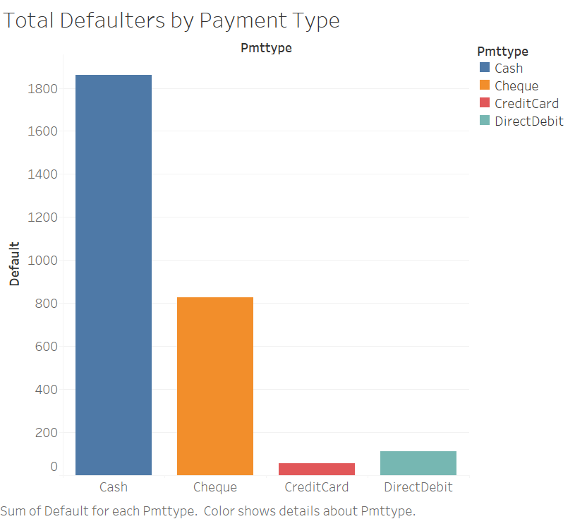

This graph explains that the highest churn rate was seen for those who used payment type as ‘Cash’ and ‘Cheque’. Whereas, credit card has the lowest churn rate Debit and credit cards may have the lowest churn rate as the subscription may be charged to the card with an auto pay while cash and cheque requires the member of the gym to physically drop in and complete the payment, thereby making it easier for them to cancel their subscription by just not turning up.

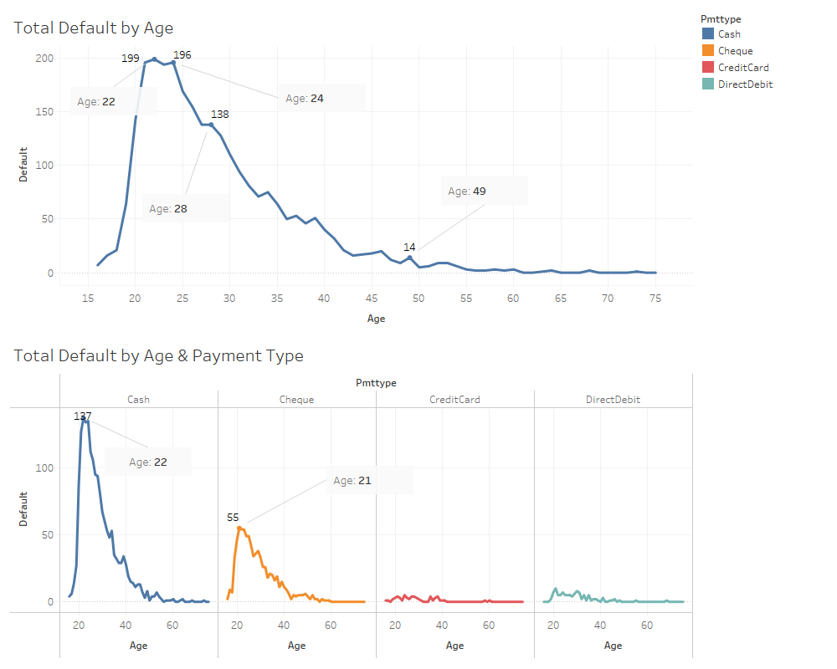

The first visual is further drilled down in the above image to identify the age with the highest churn rate. As can be seen, members in their early to mid-twenties are contributing majorly to the churn rate including in the payment type cash and cheque. This might help understand that the fitness chain caters to a young demographic who generally are just starting out their fitness journey and usually don’t have access to a credit card and debit card at that age.